PROJECT

FLOW 👍

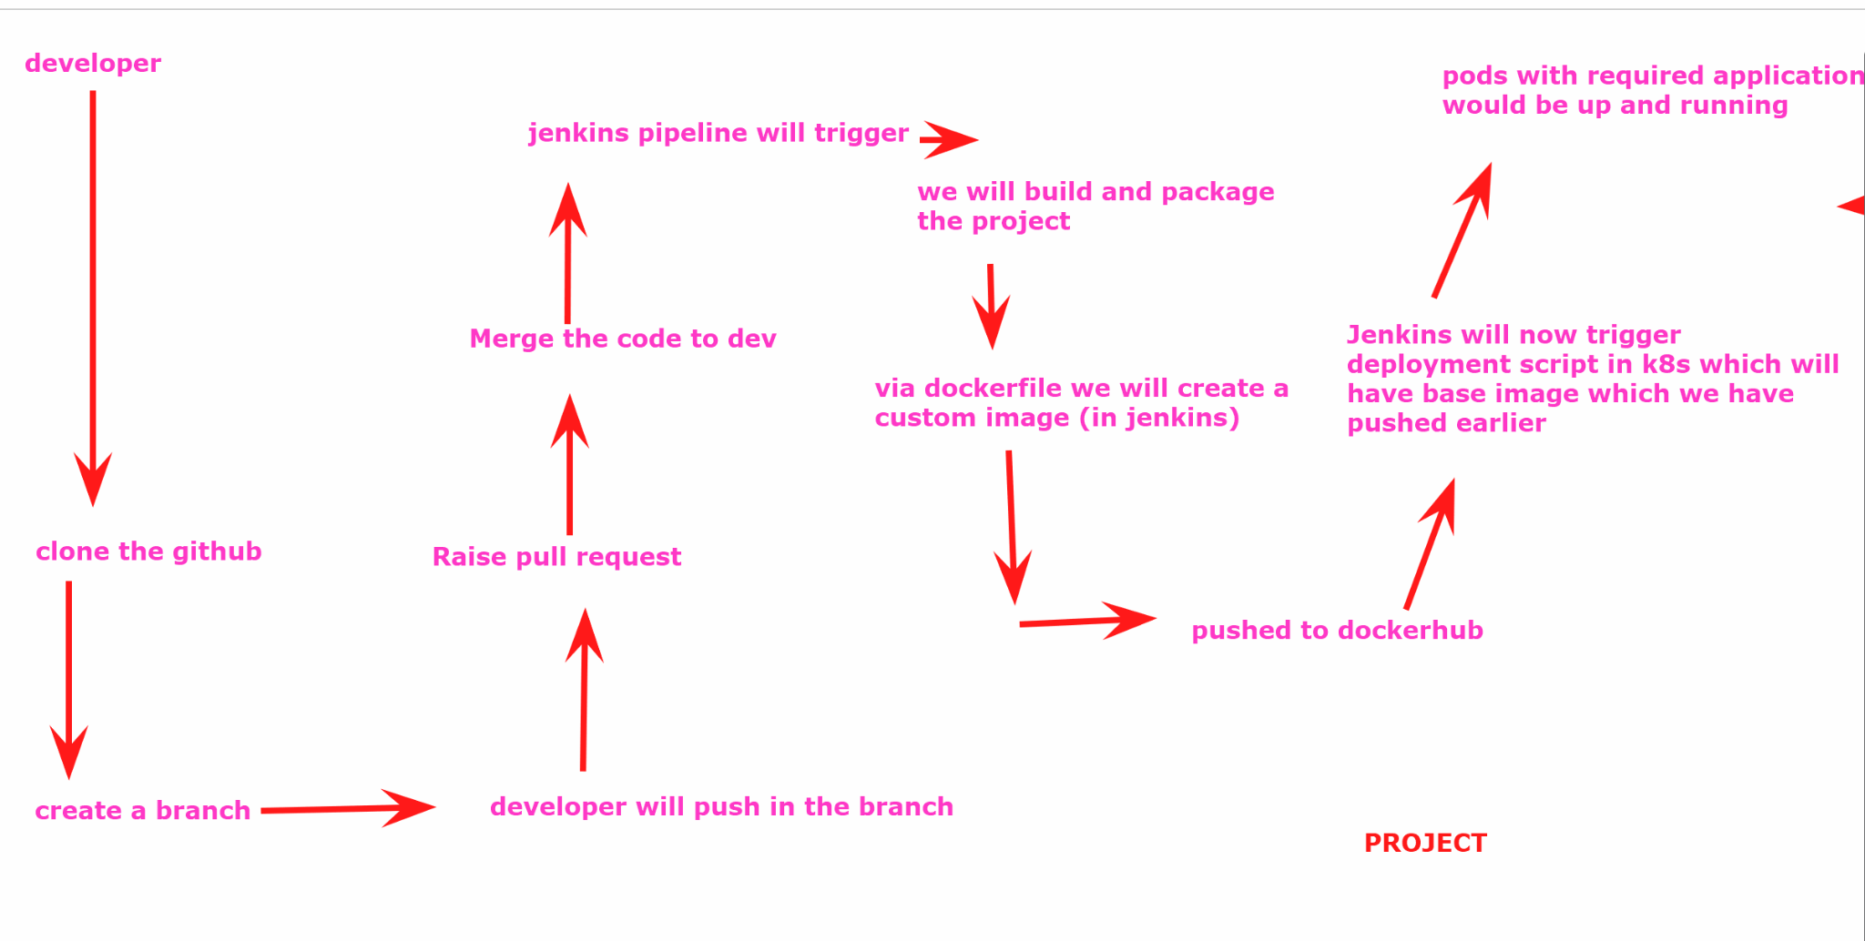

We will launch 3 aws ubuntu machines with all traffic enabled in the security group

1st machine : jenkins , docker , k8s (master machine)
2nd and 3rd machines: k8s nodes

Install Jenkins
We will install jenkins in the master machine as well:
$wget https://raw.githubusercontent.com/akshu20791/Deployment-script/main/jenkins.sh
$ls
$chmod +x jenkins.sh
$./jenkins.sh

Install docker
$sudo apt install docker.io -y
$sudo usermod -aG docker jenkins
adding user jenkins to docker group
we are allowing jenkins user to run docker cmd without needing sudo
$groups jenkins
to verify if jenkins is added to docker gp
$service jenkins restart
$visudo
jenkins ALL=(ALL:ALL) NOPASSWD: ALL
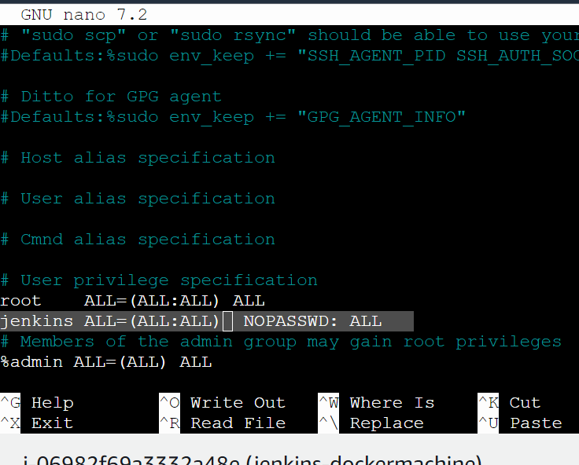

Ctrl x -> press y -> enter
$service jenkins restart
Refresh the jenkins and relogin

Install Kubernetes

Use this document to install kubernetes https://github.com/akshu20791/Deployment-script/blob/main/readme-k8s

In Master machine:
$sudo su
$wget https://raw.githubusercontent.com/akshu20791/Deployment-script/main/k8s-master.sh
$ls -l
$ls
$chmod 777 k8s-master.sh
$ls -l
$./k8s-master.sh
################# IN the nodes ###############################
$sudo su
$wget https://raw.githubusercontent.com/akshu20791/Deployment-script/main/k8s-nodes.sh
$ls
$ls -l
$chmod 777 k8s-nodes.sh
$ls -l
$./k8s-nodes.sh

###########################################################################

After k8s installation is done . we need to connect nodes with the master via tokens
### generate token in master: (run below command in k8s master)
$kubeadm token create --print-join-command

## whatever token comes up ...copy the token and paste it in notepad and after that in the command you will see 6443 written ...after that paste --cri-socket unix:///var/run/cri-dockerd.sock
EXAMPLE: YOUR TOKEN SHOULD LOOK LIKE THIS (REMEMBER NOT TO COPY BELOW TOKEN ITS NOT YOURS)
kubeadm join 172.31.17.126:6443 --cri-socket unix:///var/run/cri-dockerd.sock --token 5fh9ia.7dqyttb7tvzzarg6 --discovery-token-ca-cert-hash sha256:47a2d8b3157d6cee55109aa3a37887d031a24128de05732b0c168fe9da62733e
Now paste the tokens in the nodes one by one

#################

Fork repo, create new branch, commit changes and push new branch to github
### NOW WILL GO TO THE PROJECT REPO : https://github.com/akshu20791/cicdakshat/

Fork the project

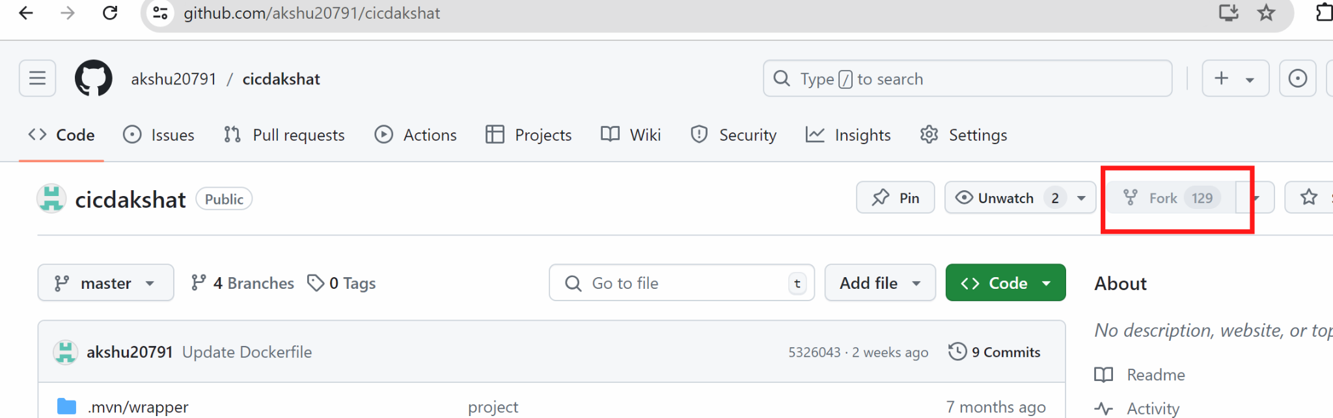

After this you can use the repo by yourself and make the changes as well

Create a new folder
Open git bash
And clone the repo
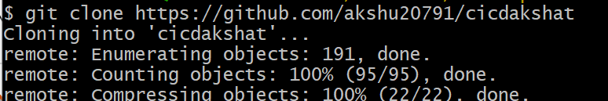
$cd cicdakshat
$git branch devops1
$git checkout devops1
Create a file …..start tracking the file …commit

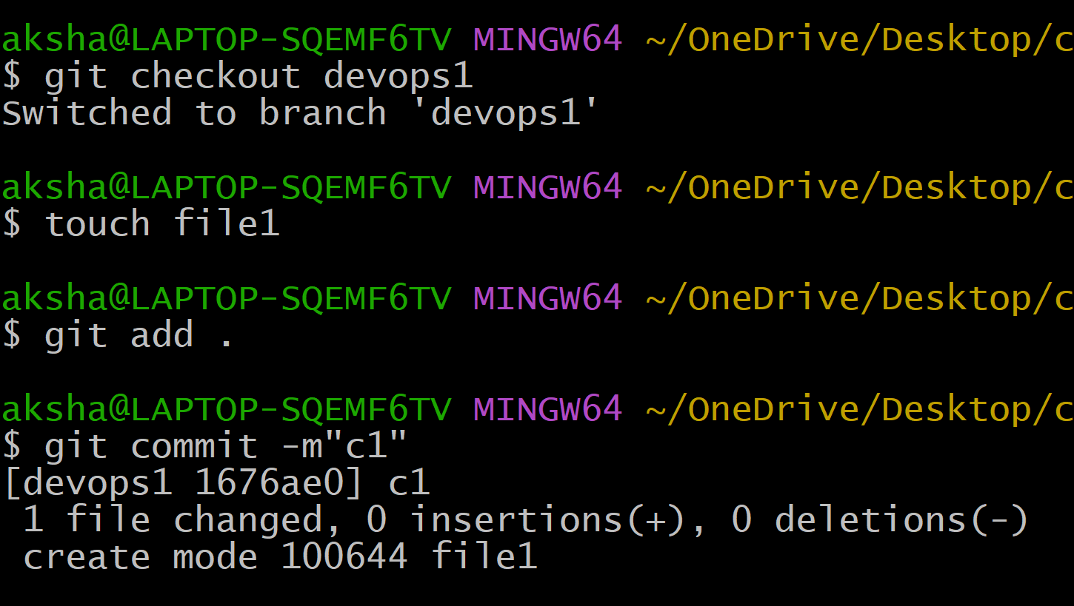
$git push -u origin devops1
(in the pop up appeared put the Personal access token for the token keys)

##########################

Raise pull request

You will go to the github repo

#merge the 2 branches but from github -> raise pull request
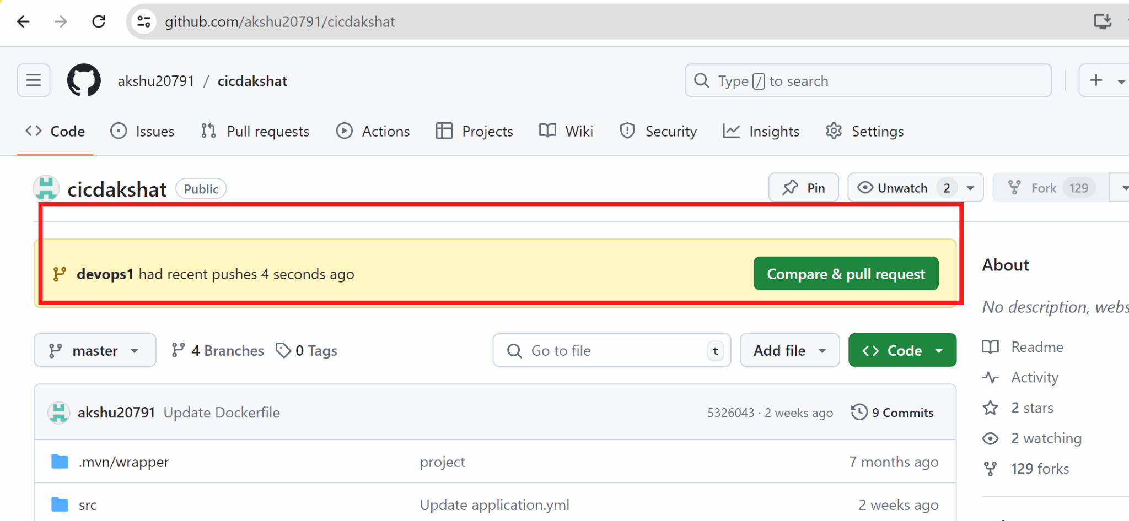

For now we will not raise the pull request…first lets create pipeline
We will open jenkins which we installed in the master

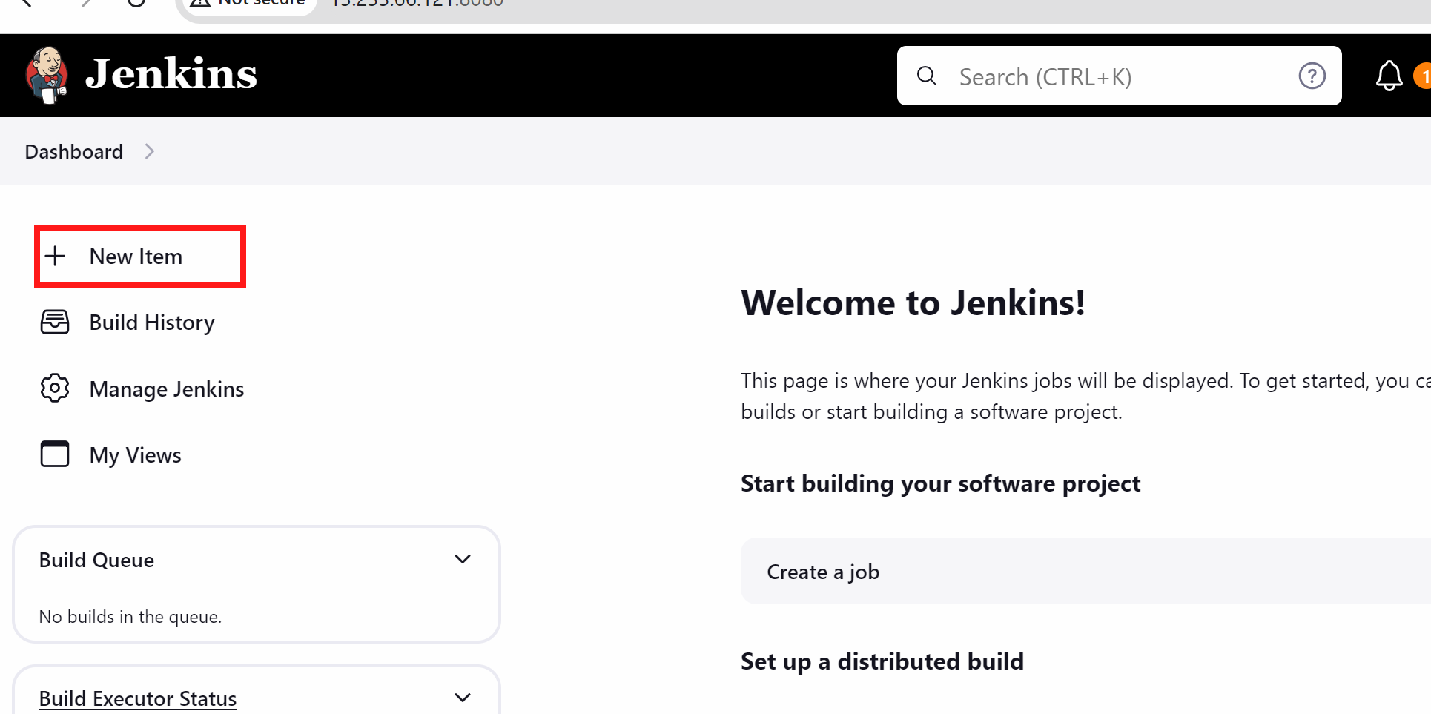

Create Multipipeline project from jenkins

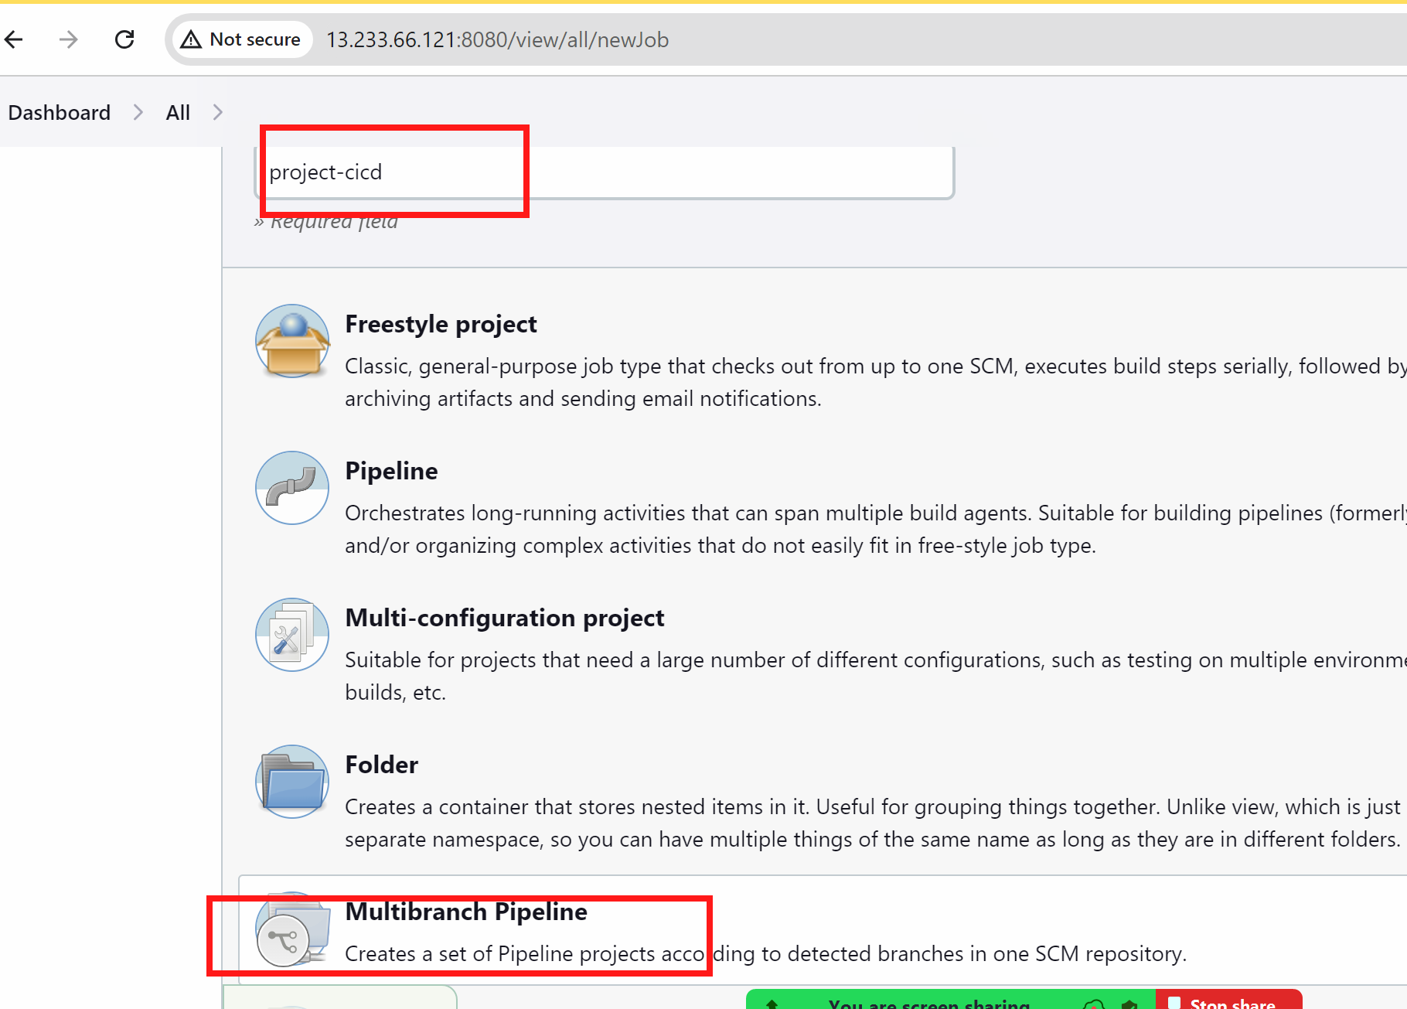

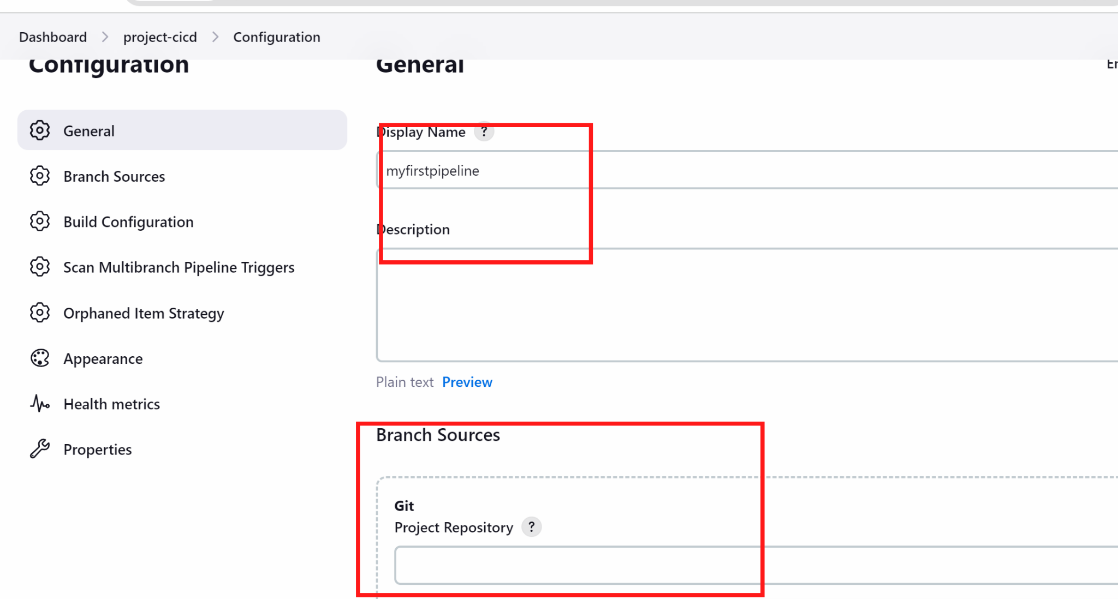

Use source as git

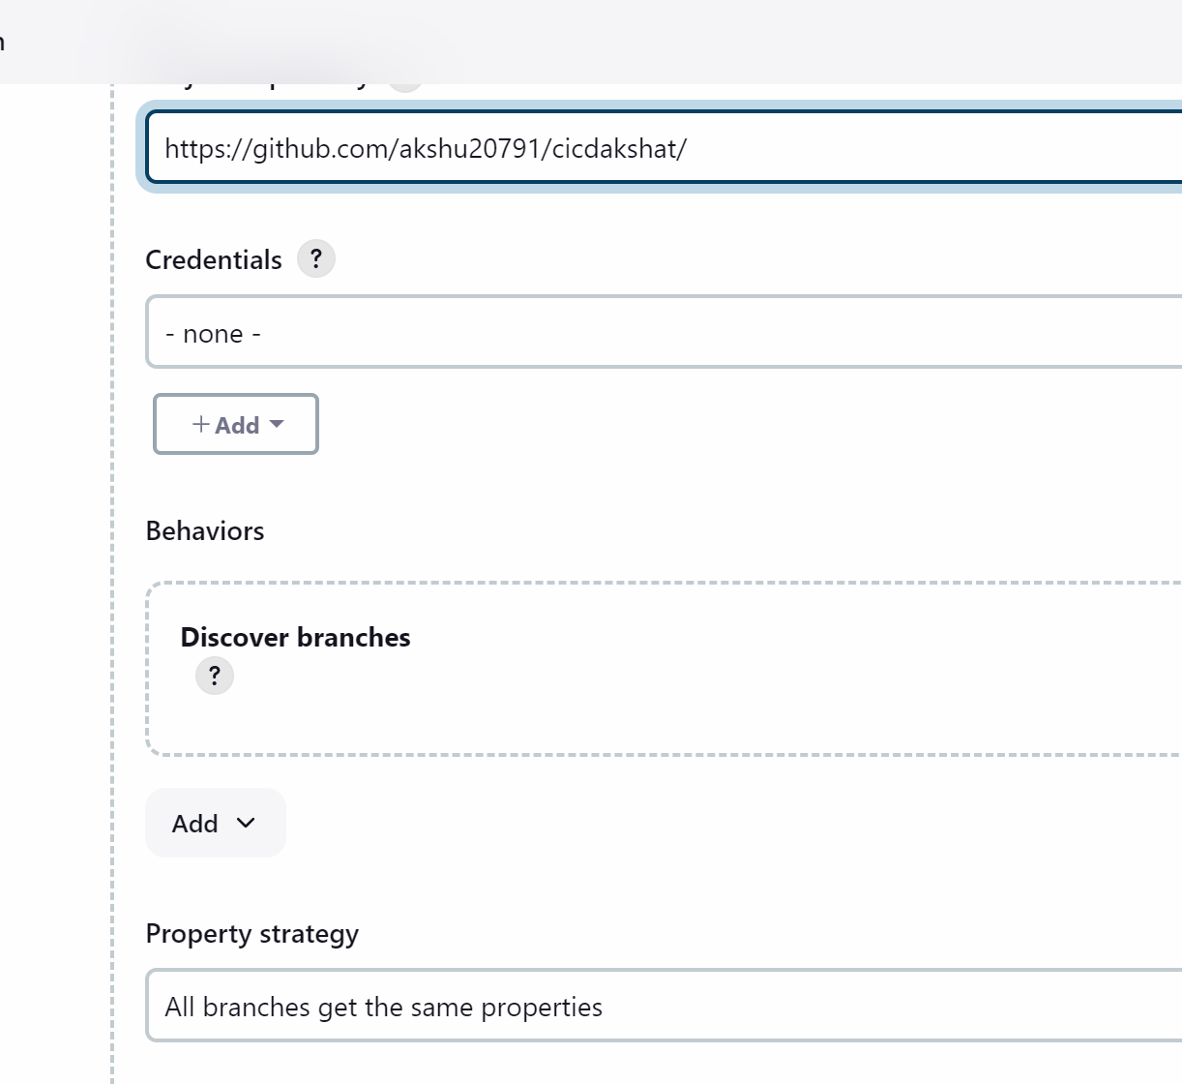

(you can put your forked branch)
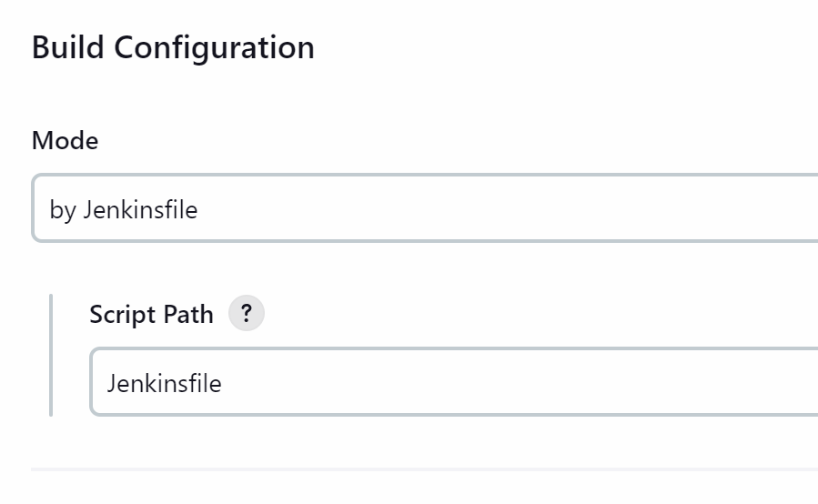

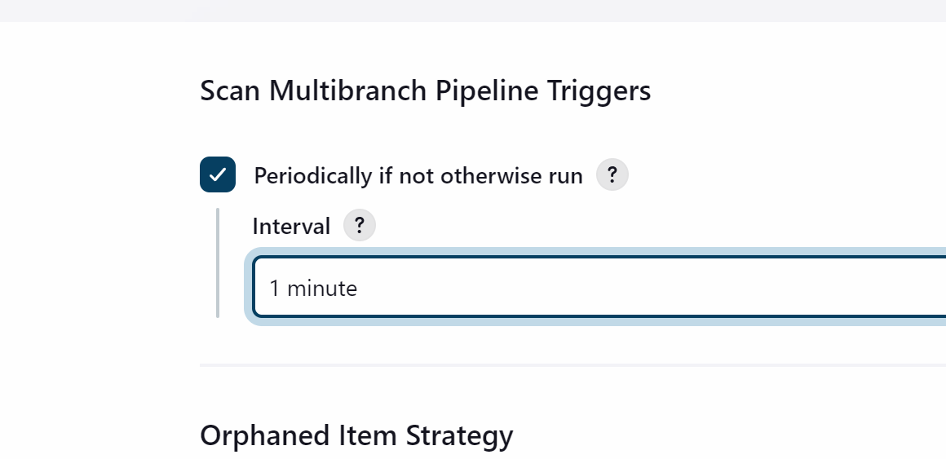

It will periodically check for every 1 min and if there is any update on github then it will build the project

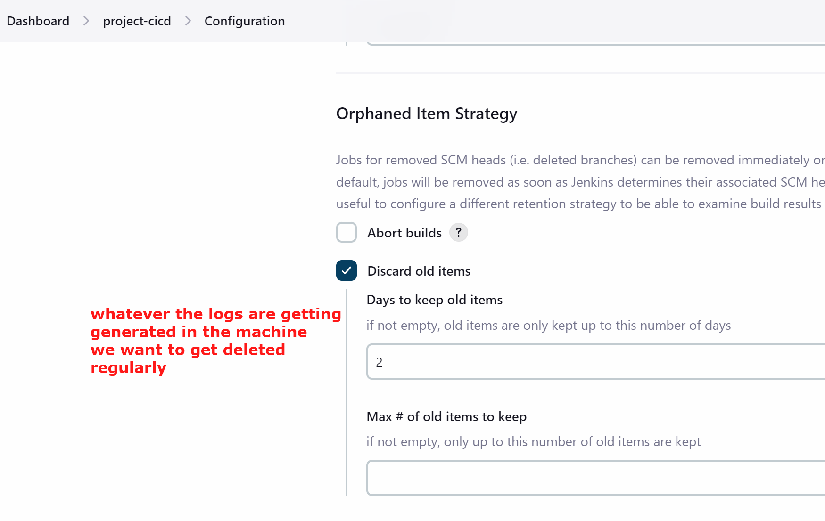

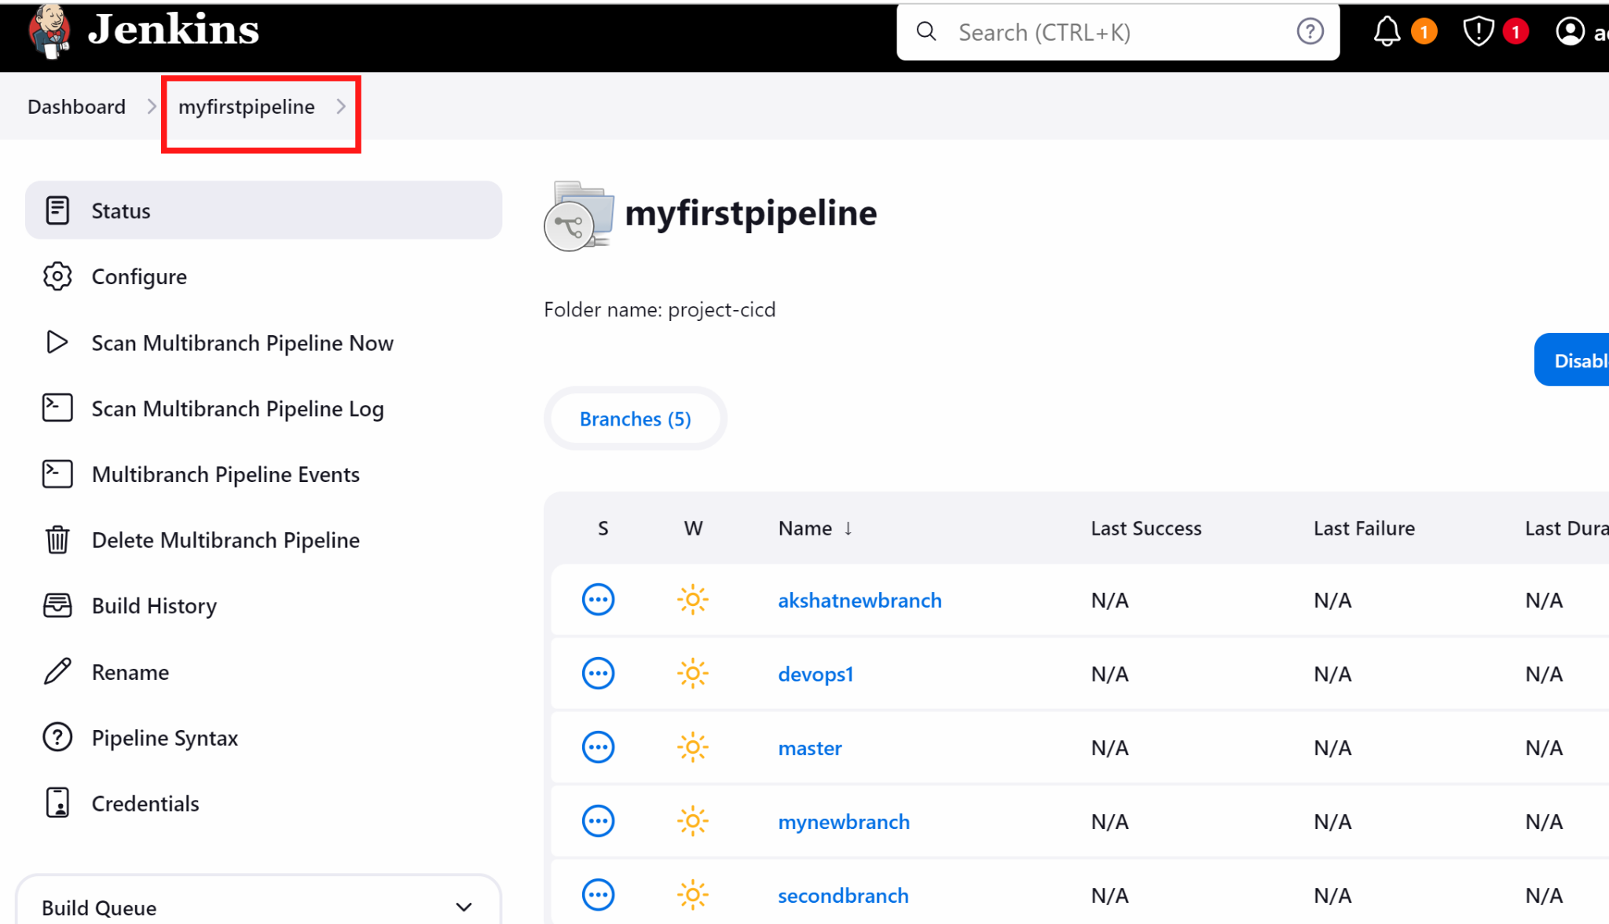

(if builds failed we are fine because we have not configured alot of things as of now)

Add dockerhub credentials in jenkins
Go to jenkins dashboard
Go to manage jenkins

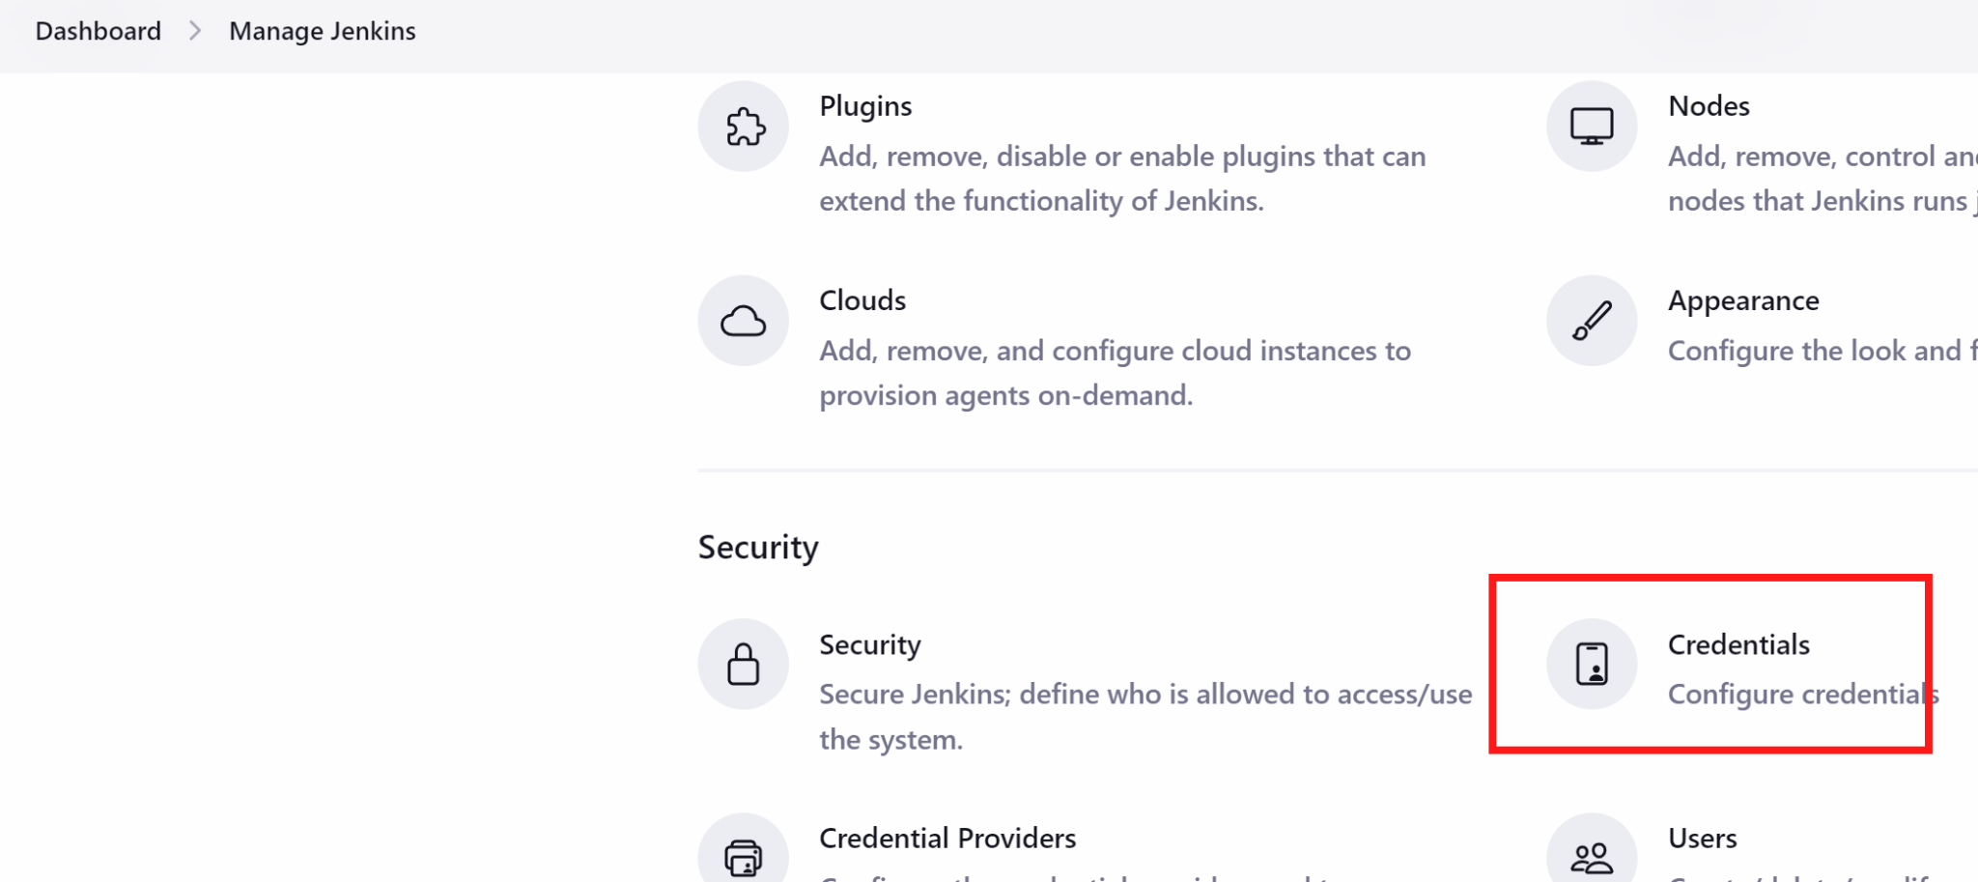

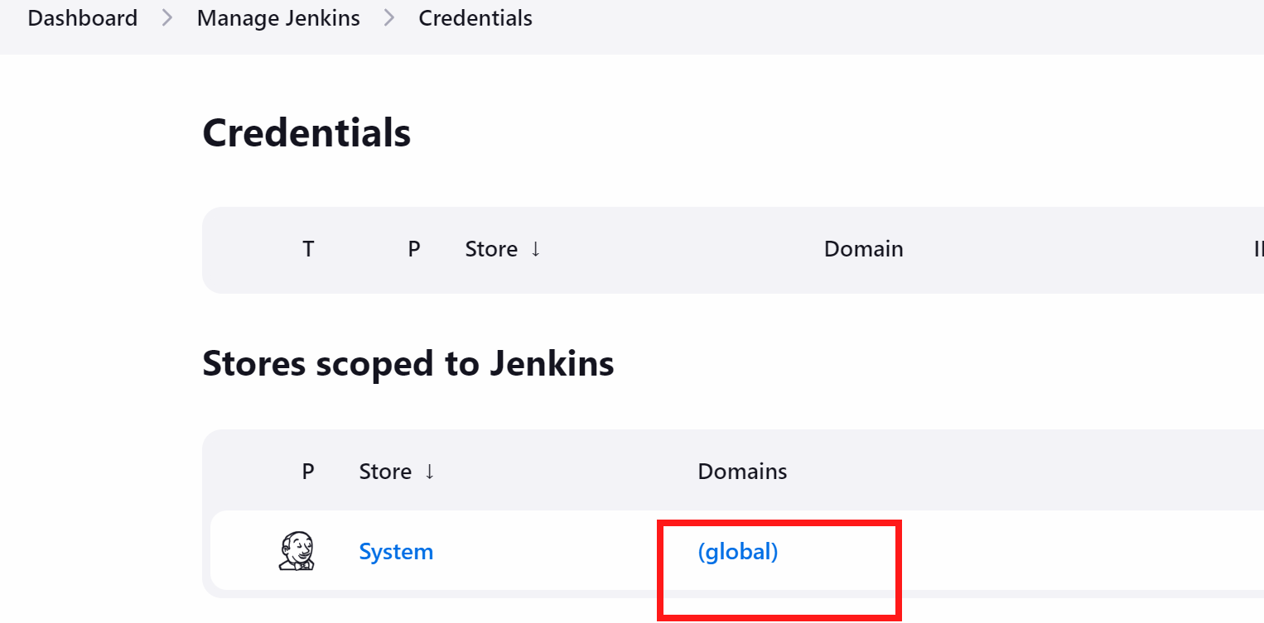

+ Add credential

Here i will be create dockerhub credentials so that my code can be pushed to dockerhub
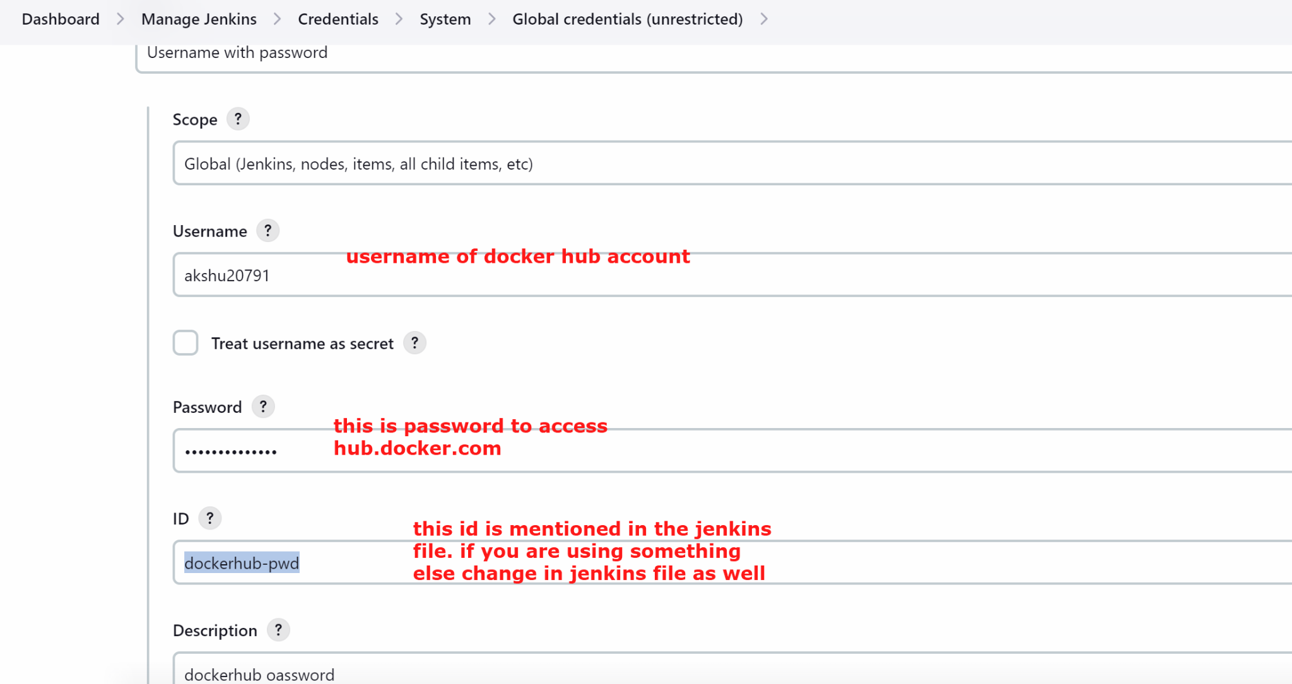

Install plugins

Go to manage jenkins
We will install docker plugins

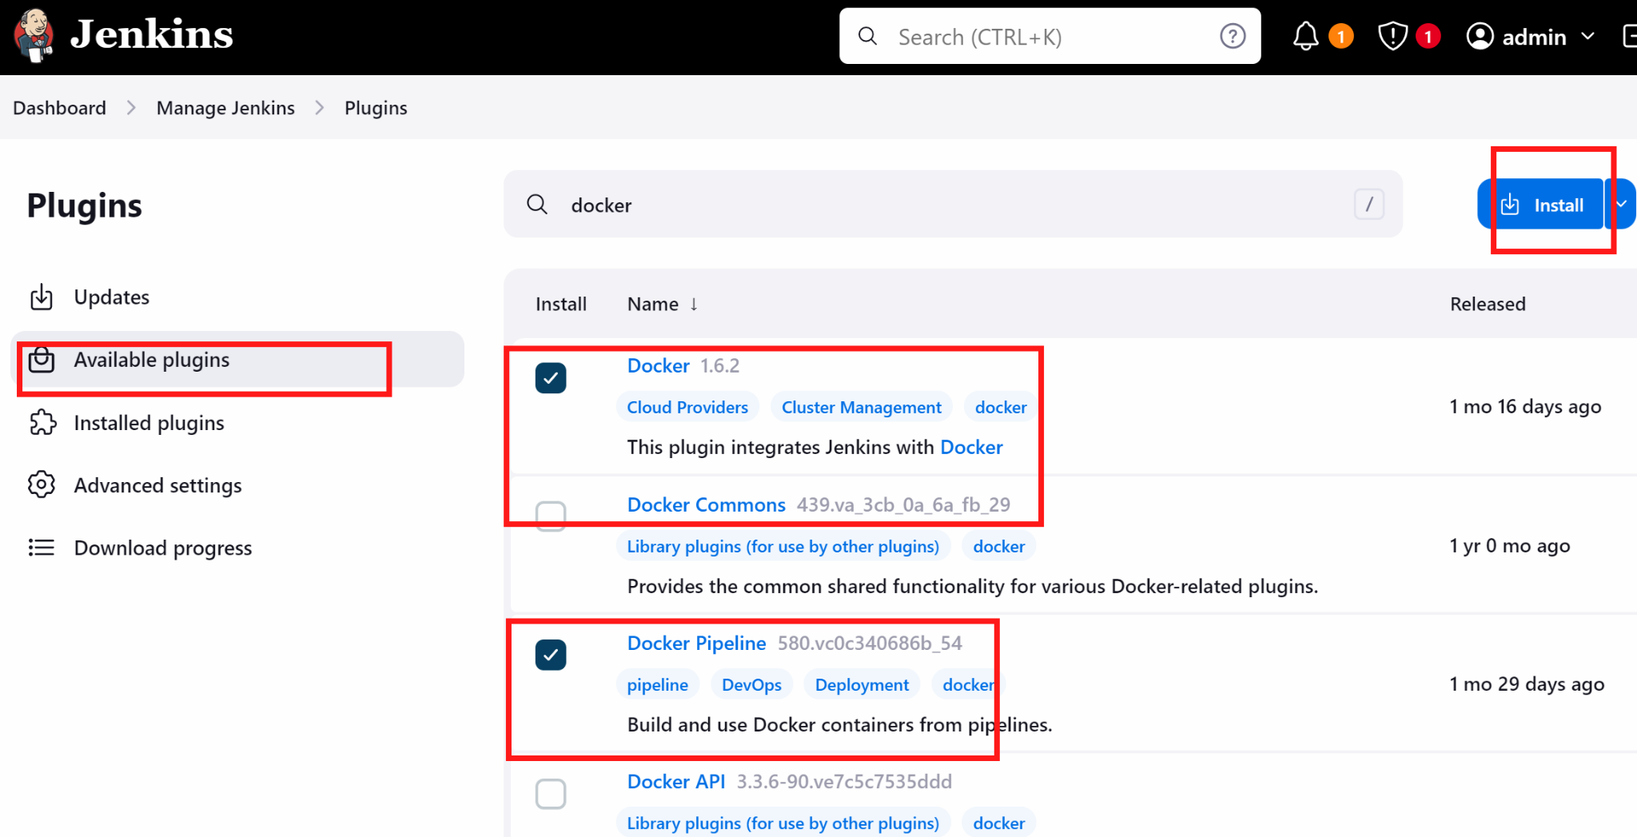

We will also install kubenetes plugin
To install kubernetes plugin 👍 -> we will download a plugin locally from github and upload it on jenkins

Go to https://github.com/akshu20791/cicdakshat/blob/master/kubernetes-cd.hpi
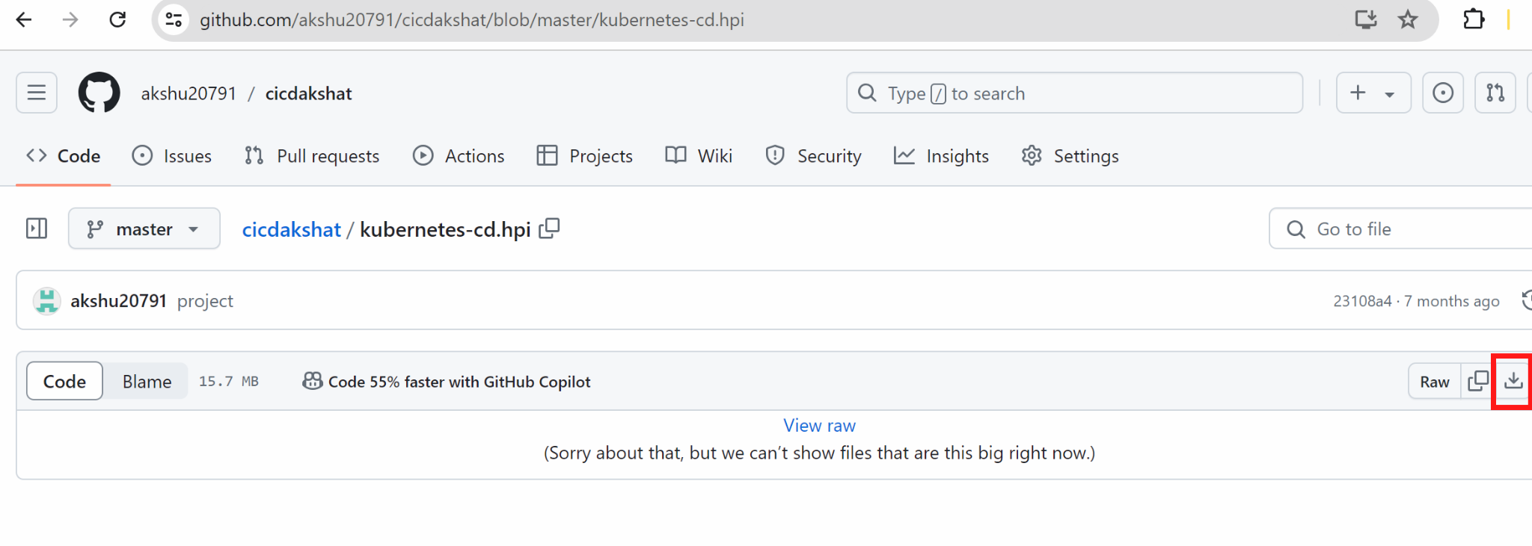

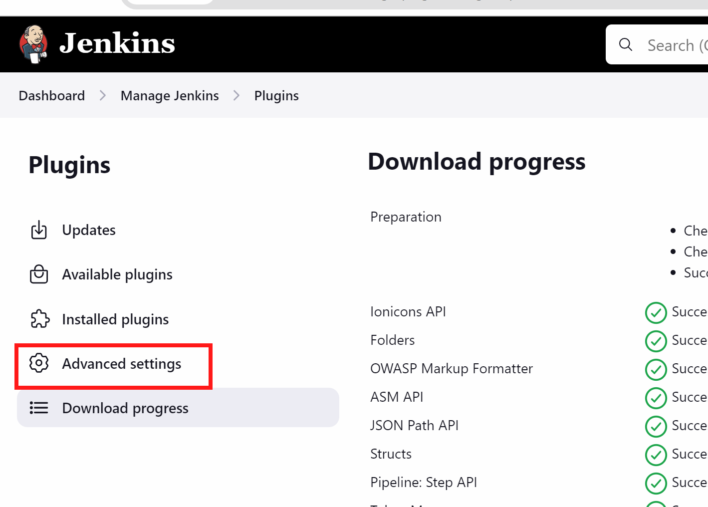

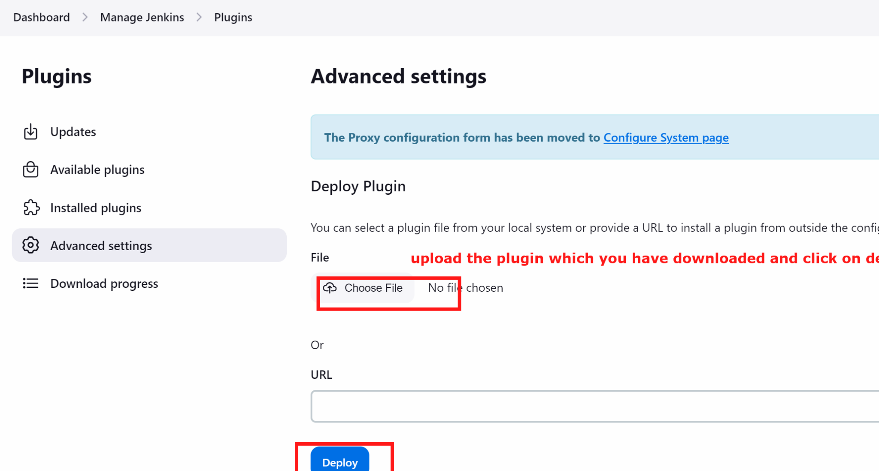

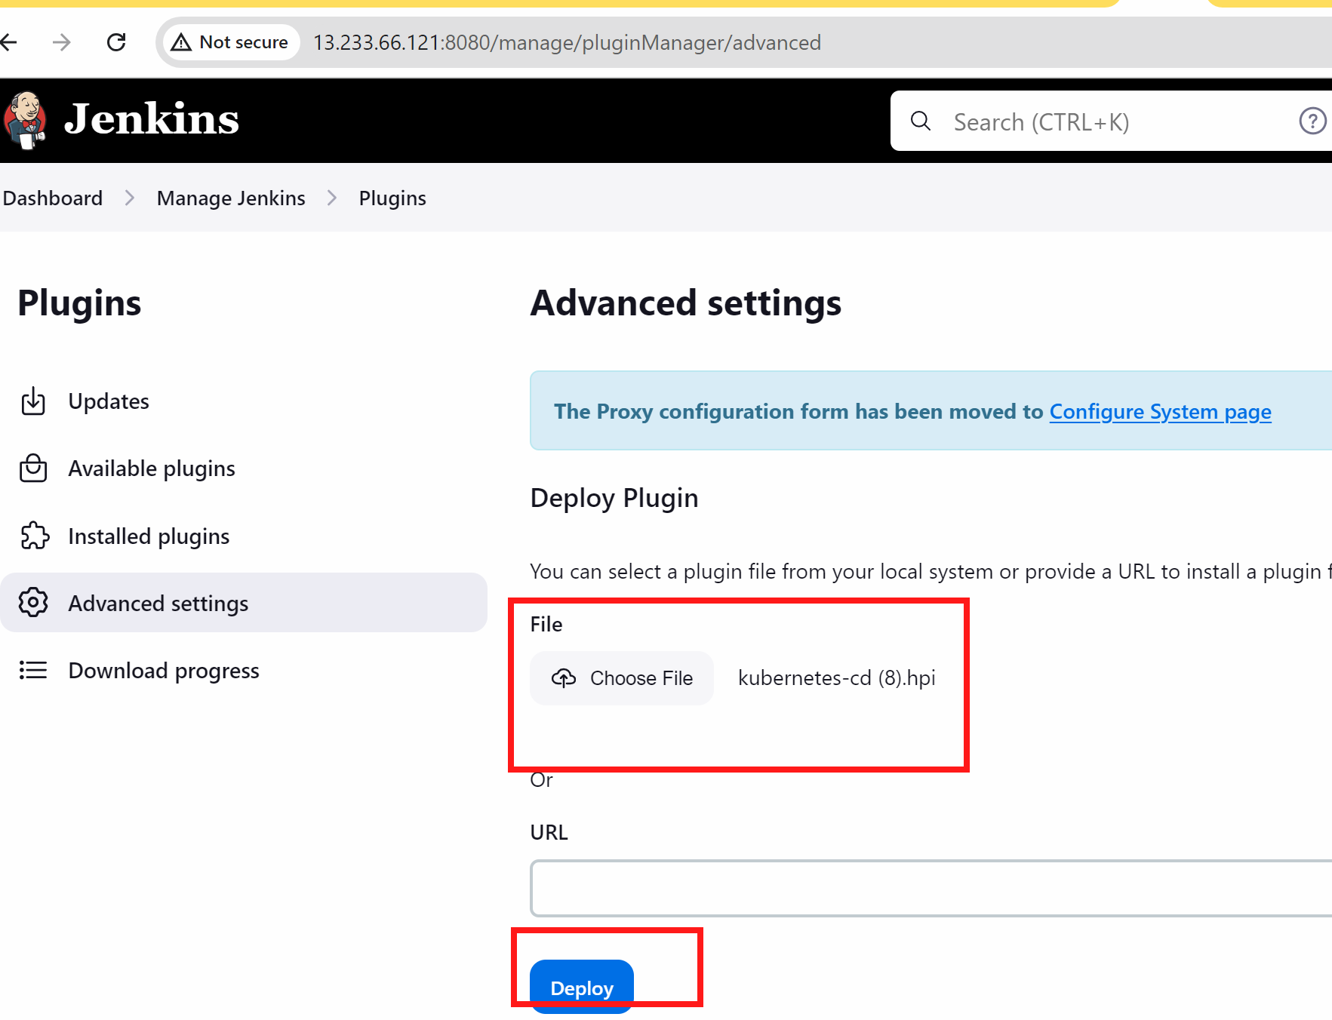

Kubeconfig in jenkins credentials
After updating it…we will generate the kubeconfigid

$cd ~
$ls -a
$cd .kube
$ls
$cat config

Copy the whole content which came up

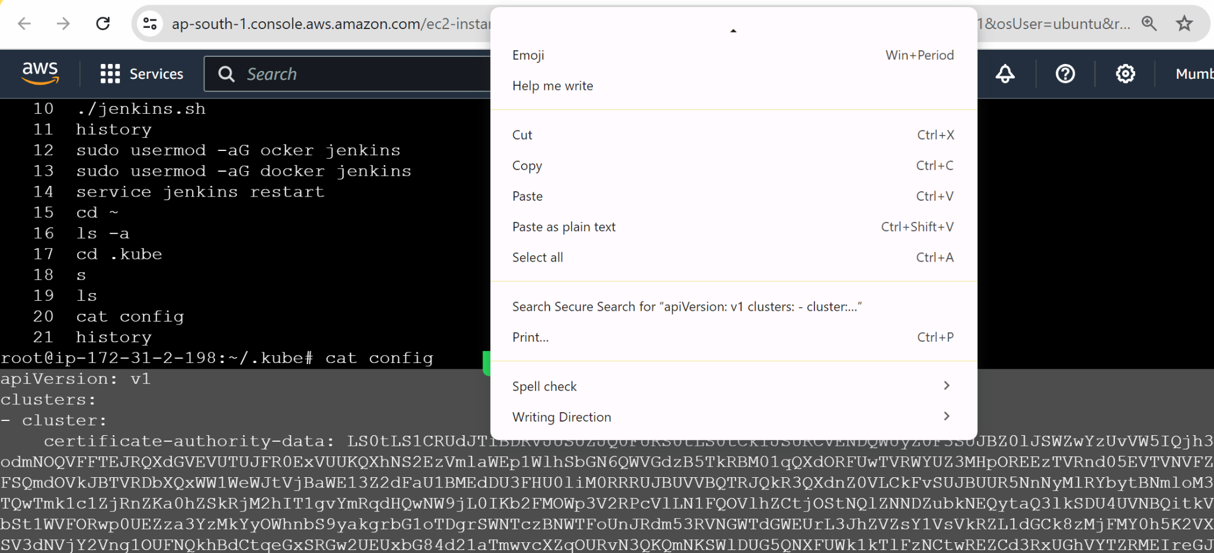

Go to jenkins - manage jenkins - credentials - global
Add credentials

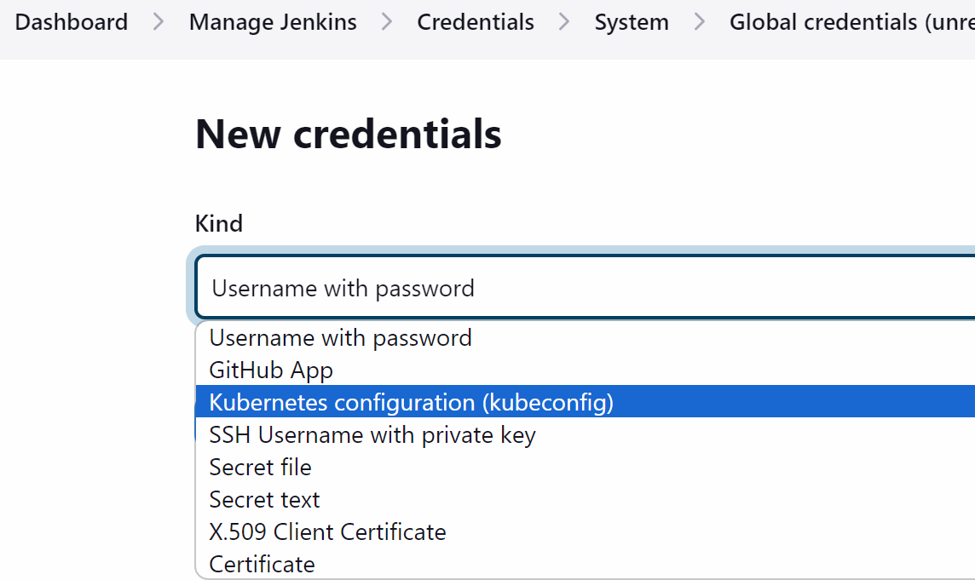

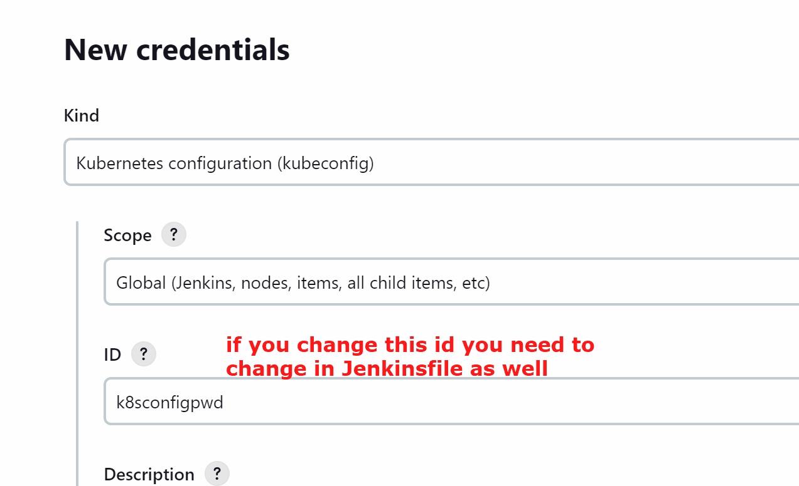

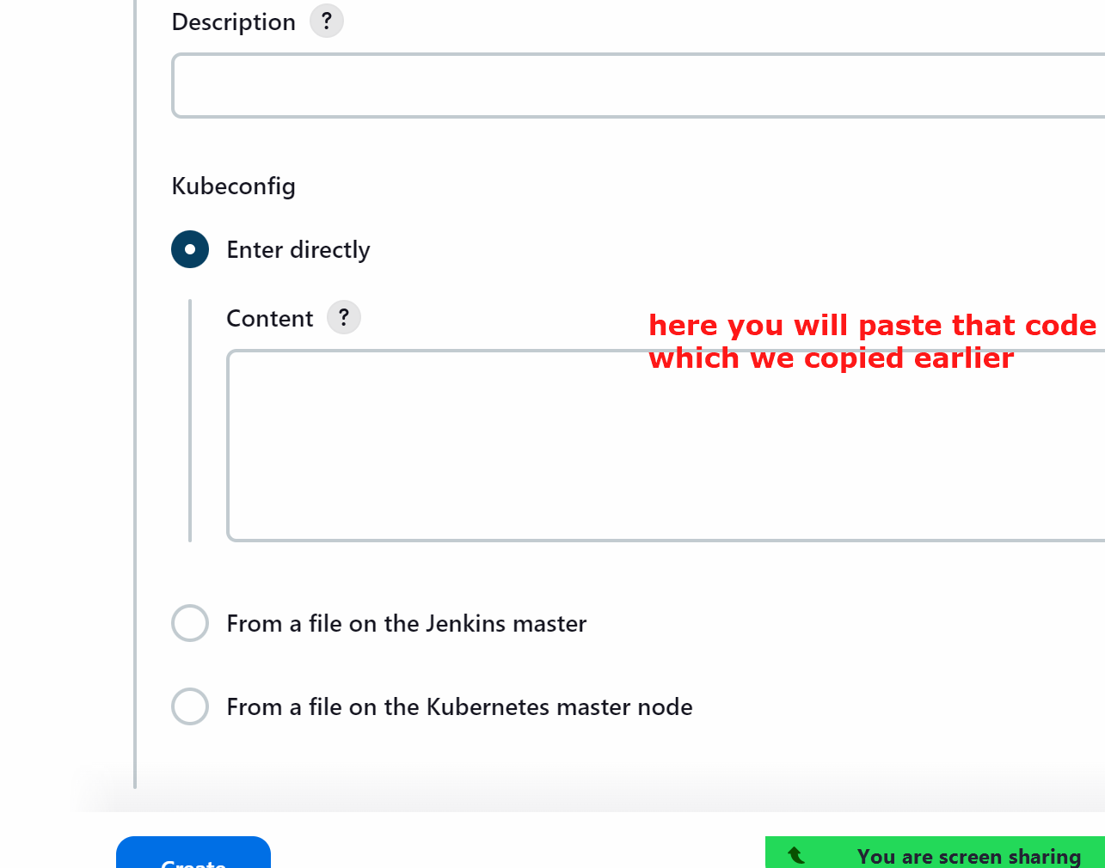

Create

Jenkinsfile
Now lets once check the jenkinsfile
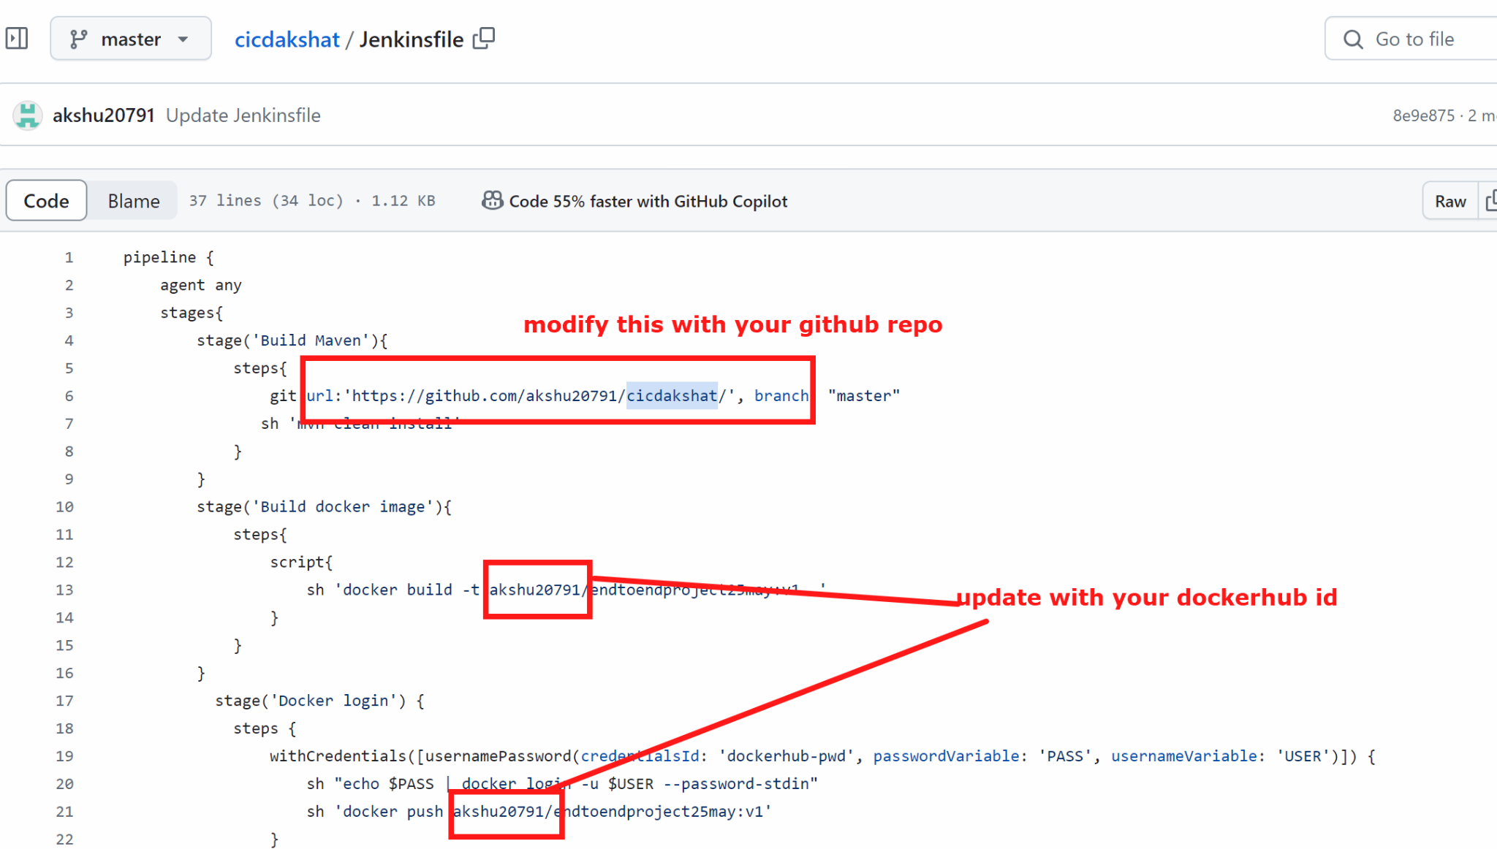

Lets execute the pipeline

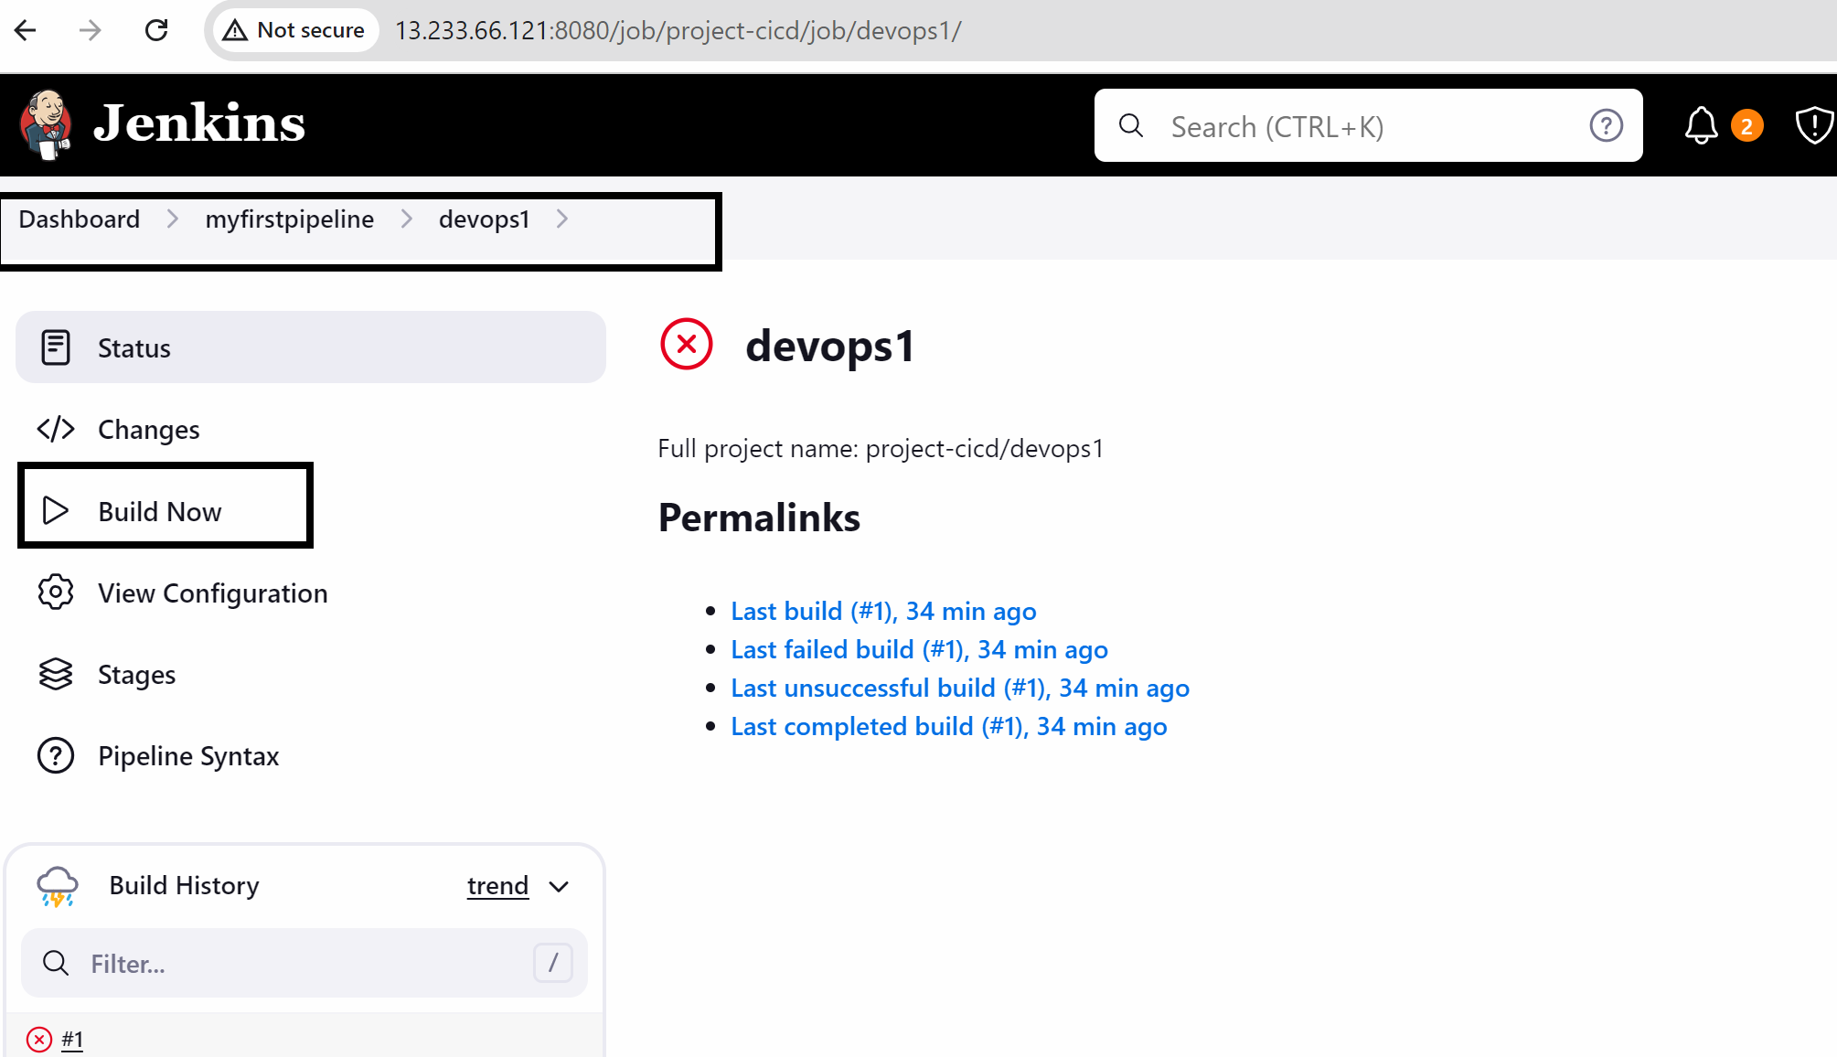

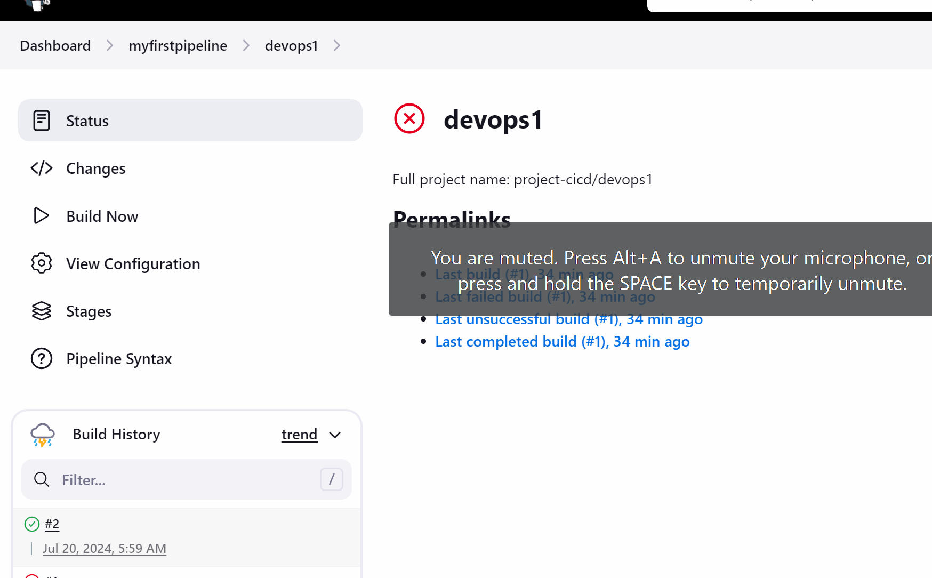

The deployment is not happening in the branch as we have put the condition in the jenkinsfile that if the branch is master then only the deployment will happen

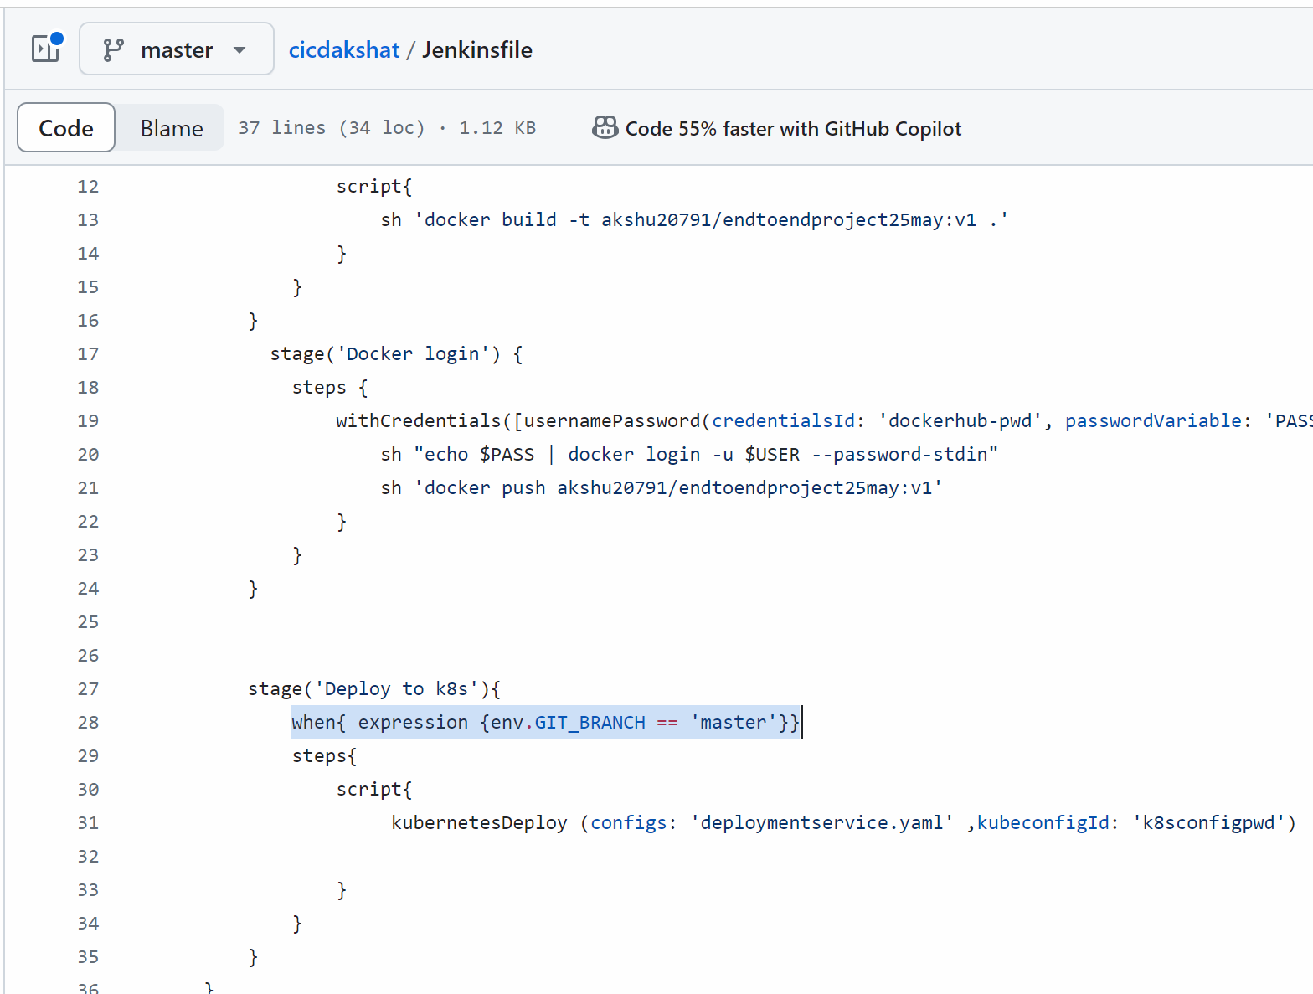

Now developer and manager is confirmed and they wanted to deploy the project…so the developer will not raise the pull request to the manager

Either you can click on pull request rab and raise pull request or

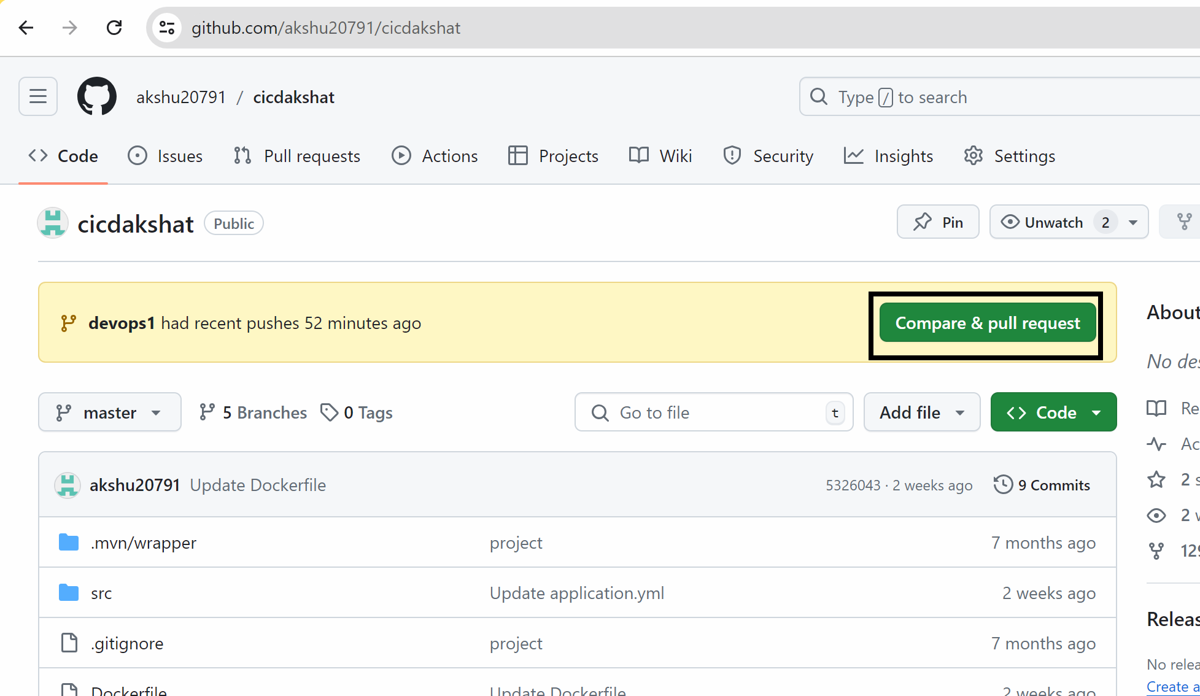

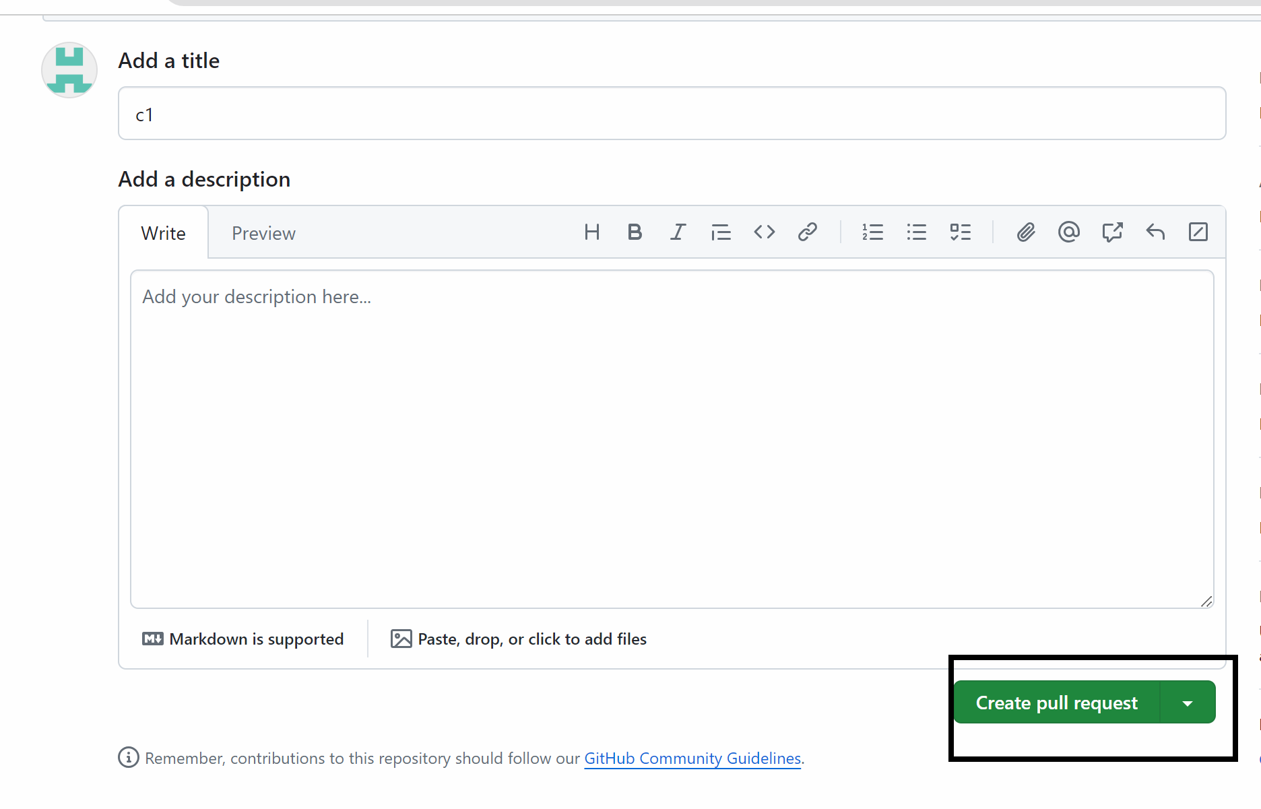

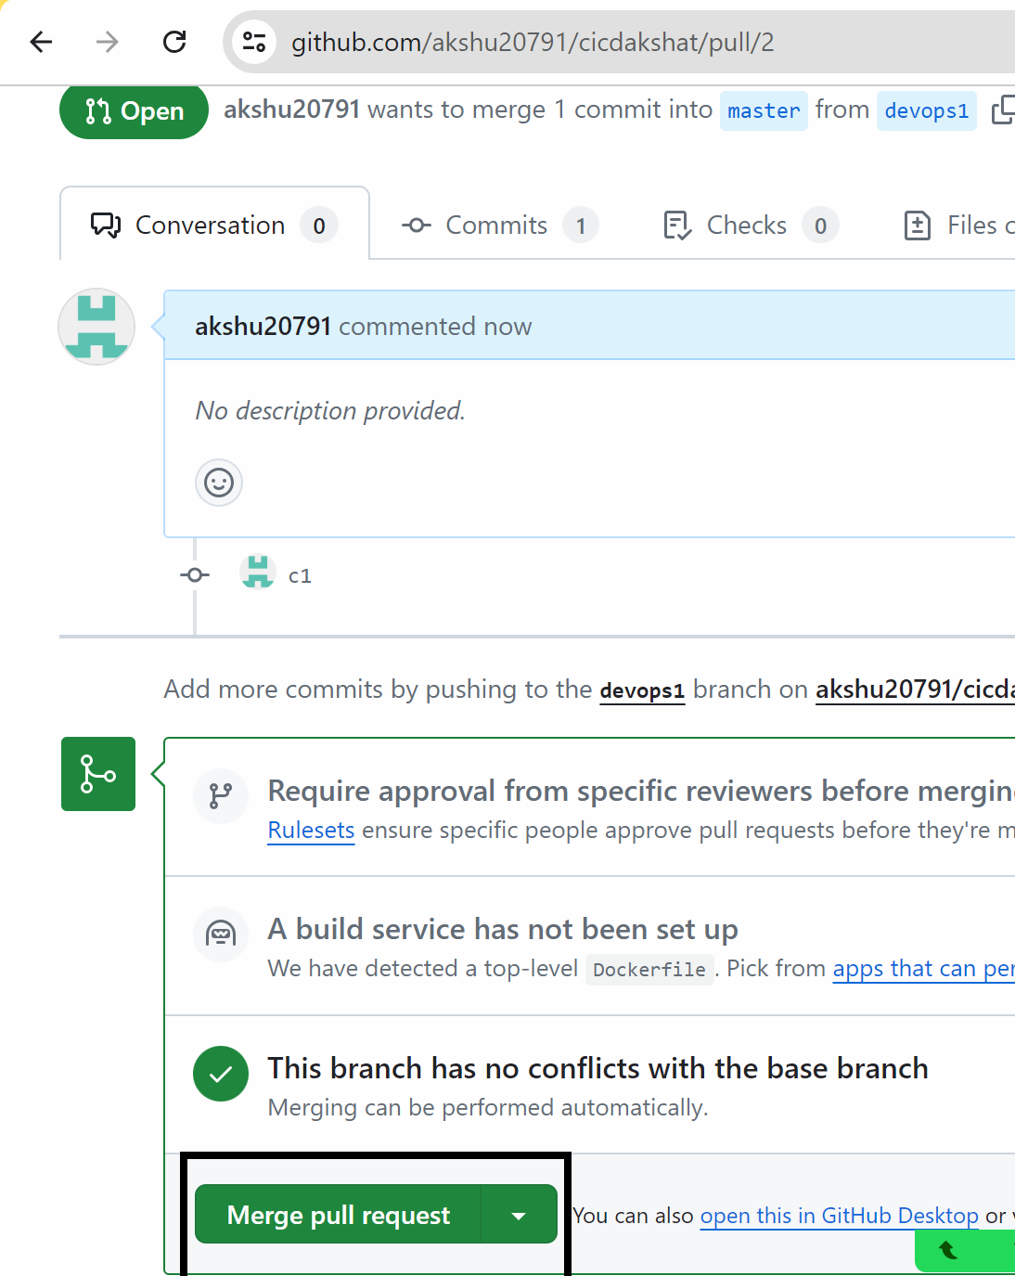

My jenkins pipeline should trigger

My master branch is triggered automatically

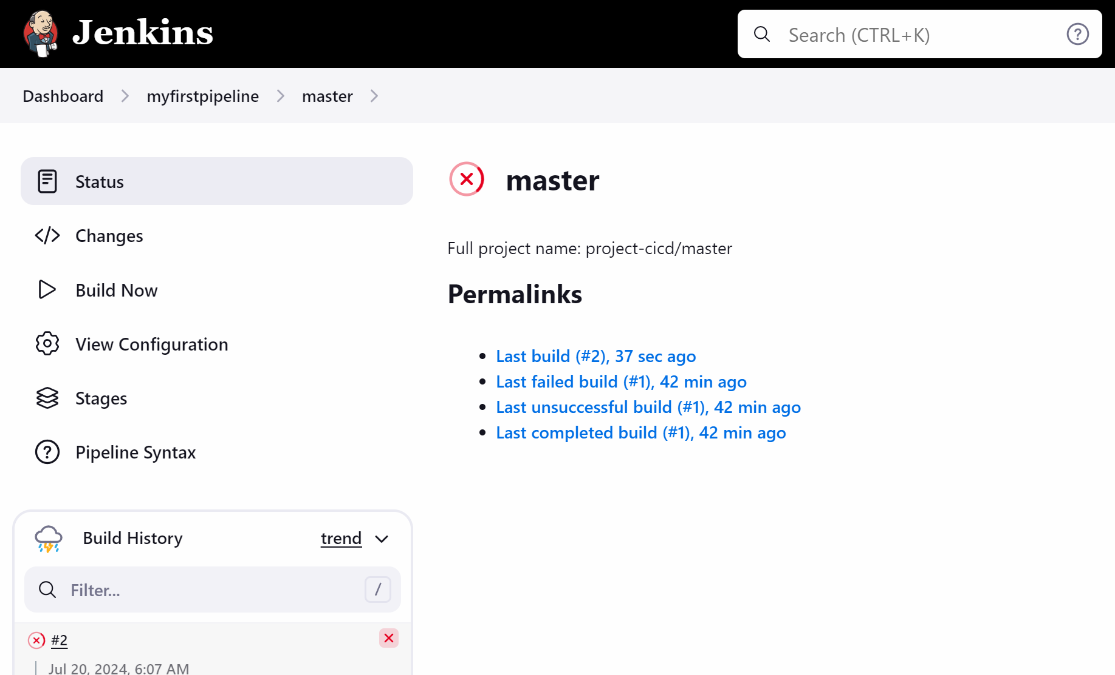

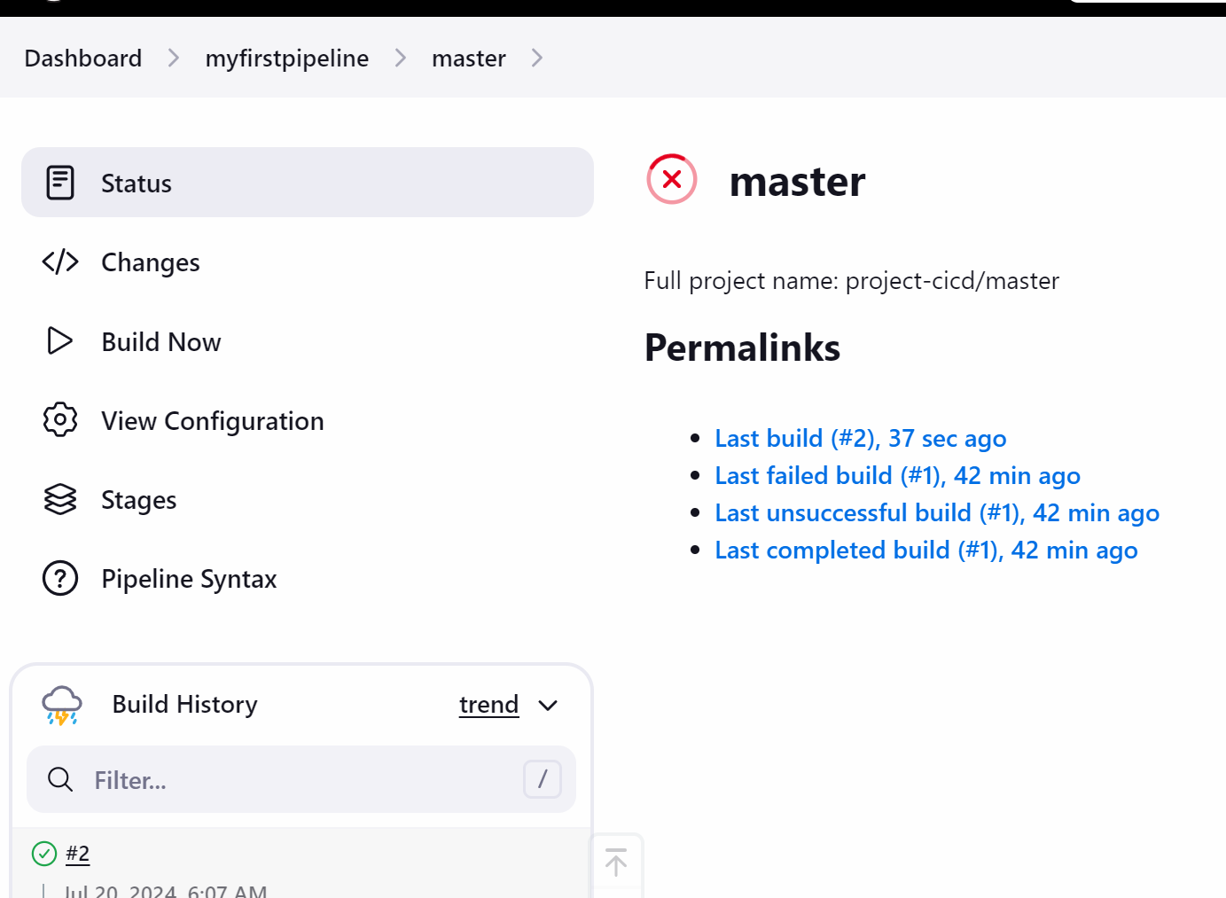

Now lets see how we can access the project

Go to master

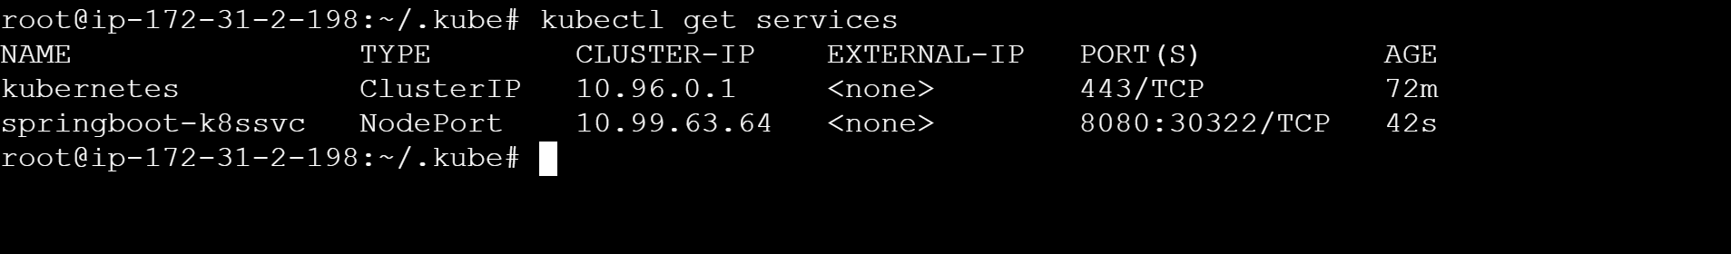

Copy the publi ip of any node :30322

